Looking into Singapore’s AirBnB Listings

Article By: Rohan Hadvani

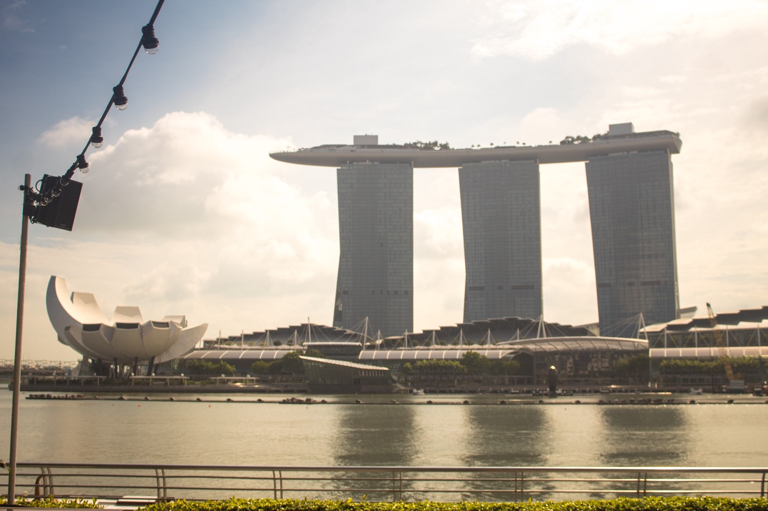

While geographically small, Singapore is an economic giant. It’s been Southeast Asia’s most prosperous city for over a century. The region blends the cultures and faiths of Malaya, Chinese, Arab, Indian and English. The special multicultural tapestry gives tourists a wide variety of sightseeing and culinary experiences to choose from. The full calendar of popular holidays and events observed during the year adds to the cultural appeal. In addition, Singapore offers luxurious hotels, tasty cuisine and excellent shopping!

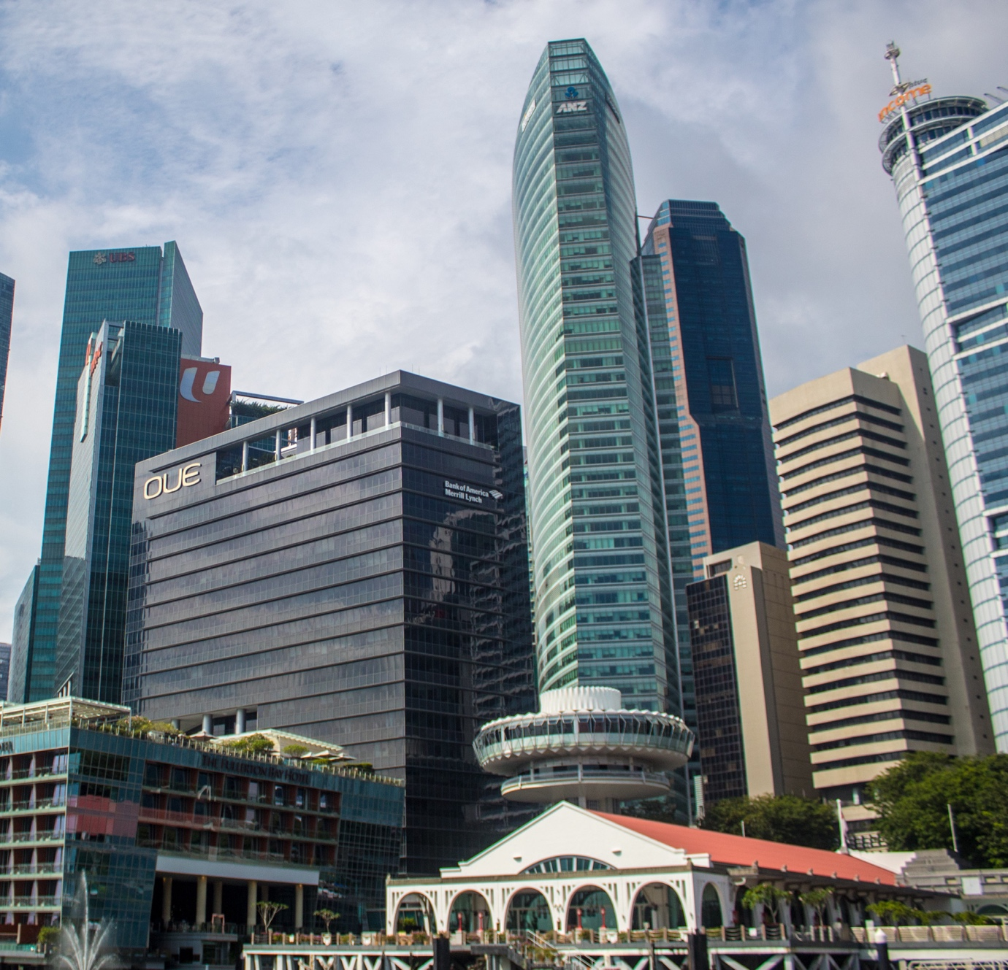

Tourism is a very big industry in Singapore. It is the world’s 5th most visited country and 2nd most in Asia pacific. Naturally, the number of hotels and AirBnBs in Singapore will be huge. In this blog post, we are going to analyze the listings database of Singapore from Airbnb.

Airbnb is one of the biggest sites in the world for exclusive, affordable places to live and things to do, providing more than 7 million accommodation and 50,000 handcrafted events, all operated by local hosts. As an economic transformation driver, Airbnb has helped millions of hospitality pioneers monetize their spaces and desires while retaining the financial advantages of tourism in their own communities. With more than three-quarters of a billion visitors arriving to date and available in 62 languages spanning 220 + countries and continents, Airbnb encourages people-to-people, culture and trust around the world.

From the dataset, we are going to answer the following questions that will come to anyone’s mind when booking an Airbnb:

1. What are room types do guests prefer the most?
2. Which neighbourhood of Singapore has the maximum number of properties?
3. Which neighbourhood is the most expensive?
4. Which area of Singapore has the maximum reviewed properties?
5. Which properties are available for how many days?
6. What are the basic amenities offered and is the price of the property associated with luxury amenities?

**Question 1: Room types prefered by guests**

This the first question which comes to mind. What do the majority of the people book?

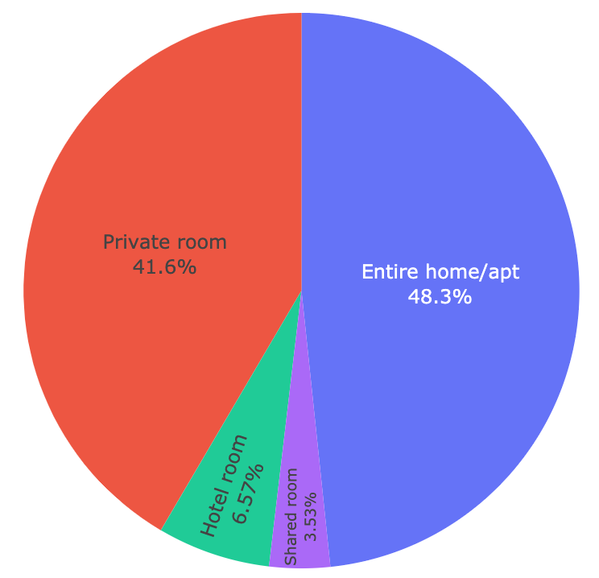

From this chart, we can see that the entire home/apt is preferred by most of the people followed by private rooms.

Let's see how these room types are distributed all over Singapore.

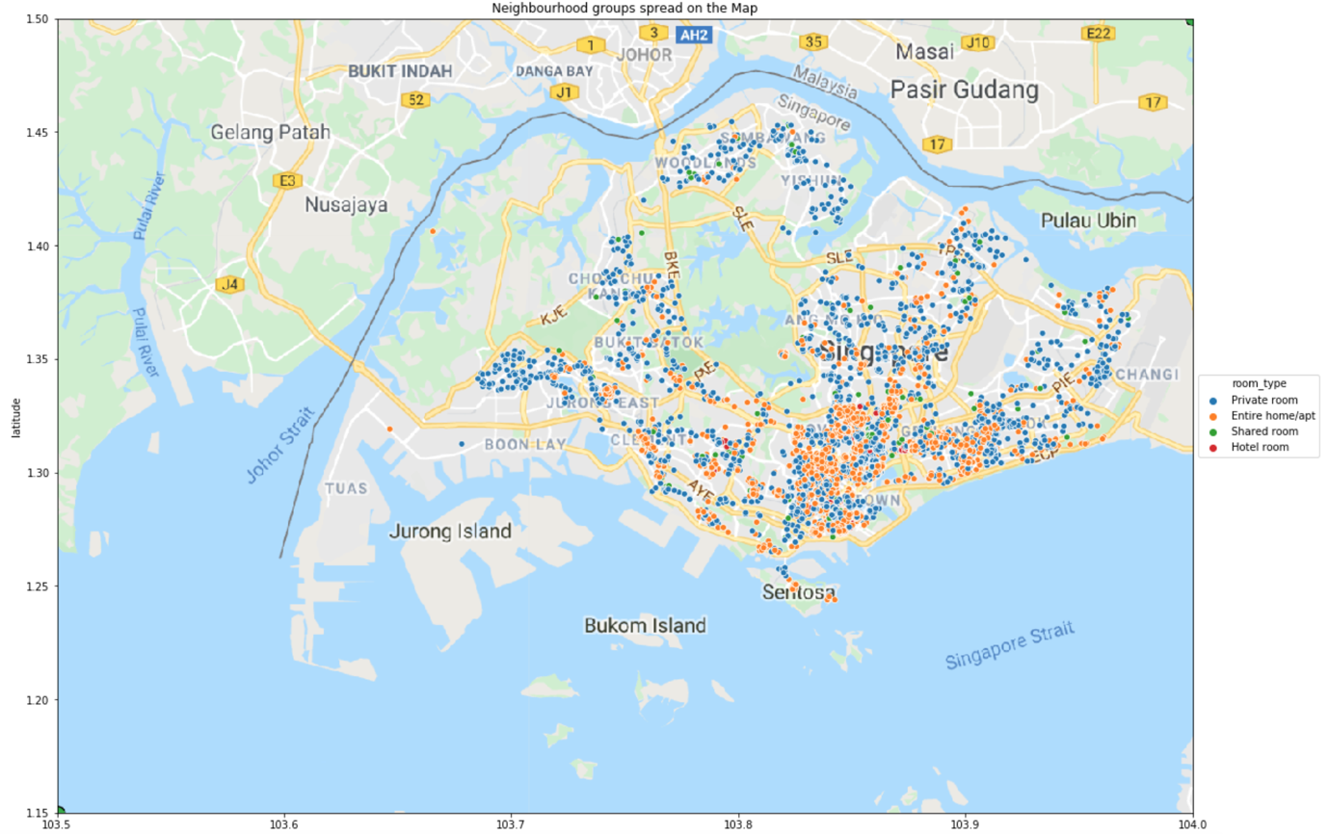

Map of Singapore showing location of various types of rooms.

**Question 2: Neighbourhoods of Singapore**

Let us see where the maximum properties are located in Singapore.

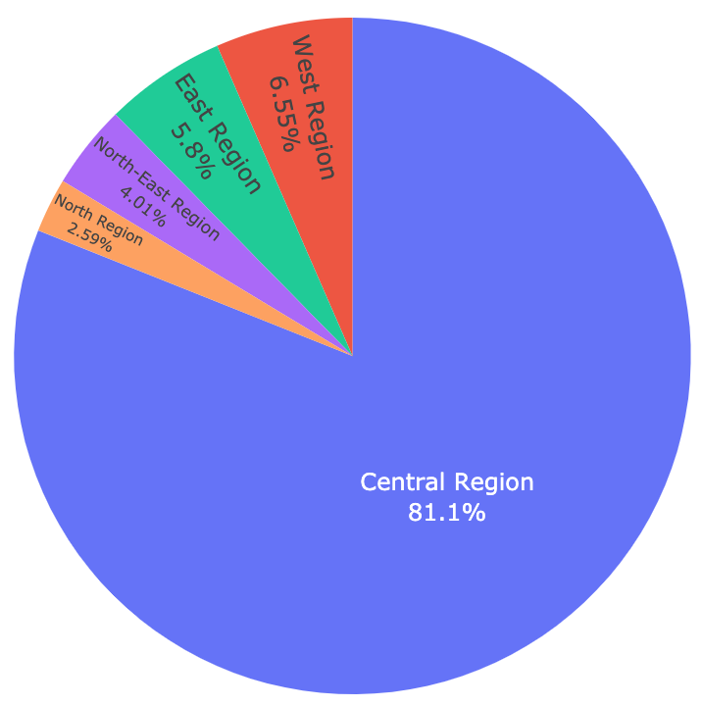

The majority of the properties are located in the central region of Singapore. The central region is the area which has the downtown area, marina, Sentosa etc. All the major attractions will be walking distance anywhere in the central region or just a 2 3 stop MRT ride.

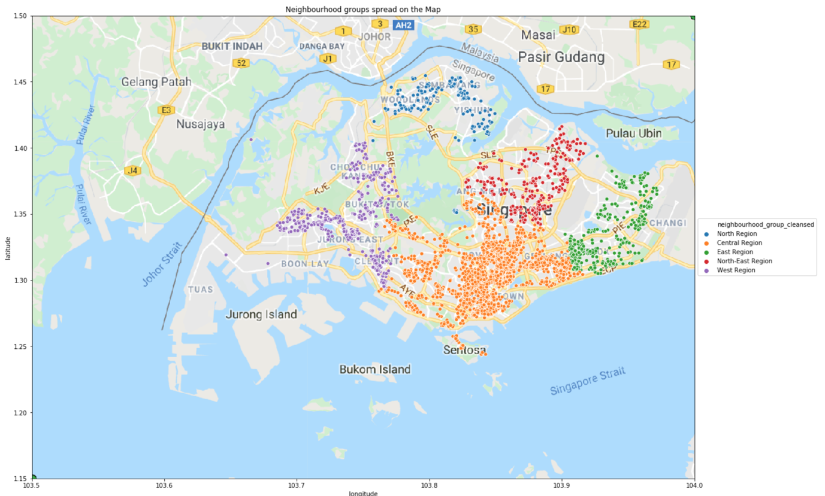

Locations of the various regions of Singapore

**Question 3: Expensive neighbourhoods of Singapore**

For analysing this question we have selected the properties below 500 dollars because above that only 3% of properties exist and they can create problems with the analysis.

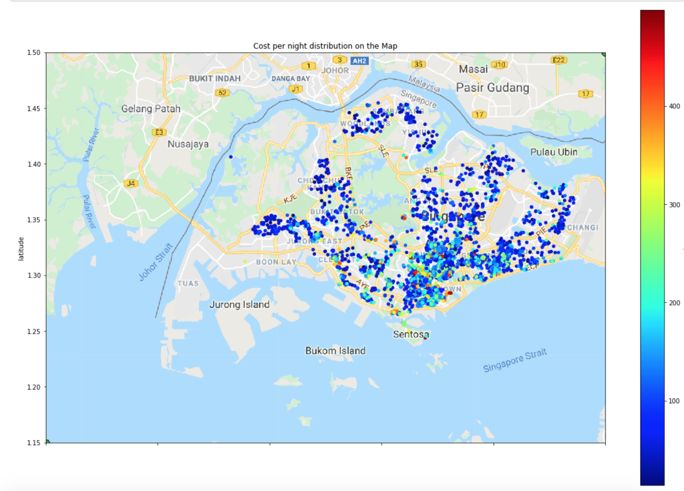

Map of Singapore showing the location of most expensive properties

From the above map of Singapore, we can see that majority of the costly properties are present in the central areas of Singapore.

Plotting the price area wise:

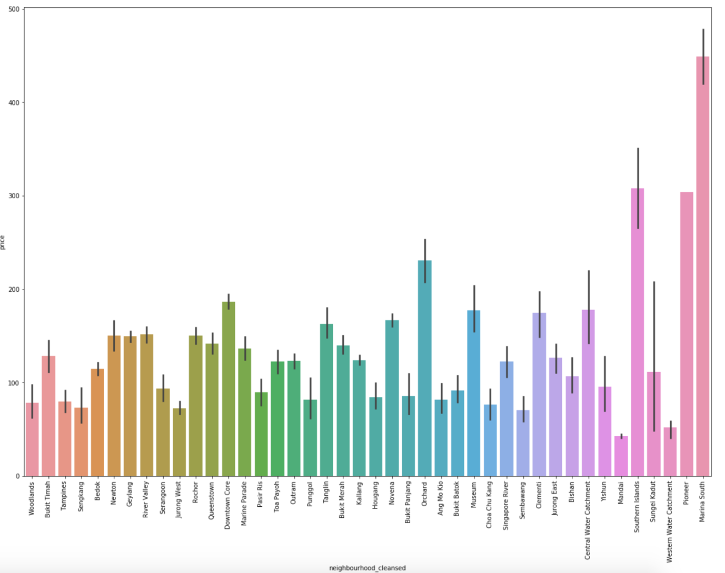

Bar graph of neighbourhood vs price

Areas like marina south, pioneer, southern islands, central water catchment are the most expensive ones.

**Question 4 Most reviewed properties**

When analysing the data we found the many properties were reviewed just once while some were reviewed more than 200 times. So for this question, we have selected only the top 500 places.

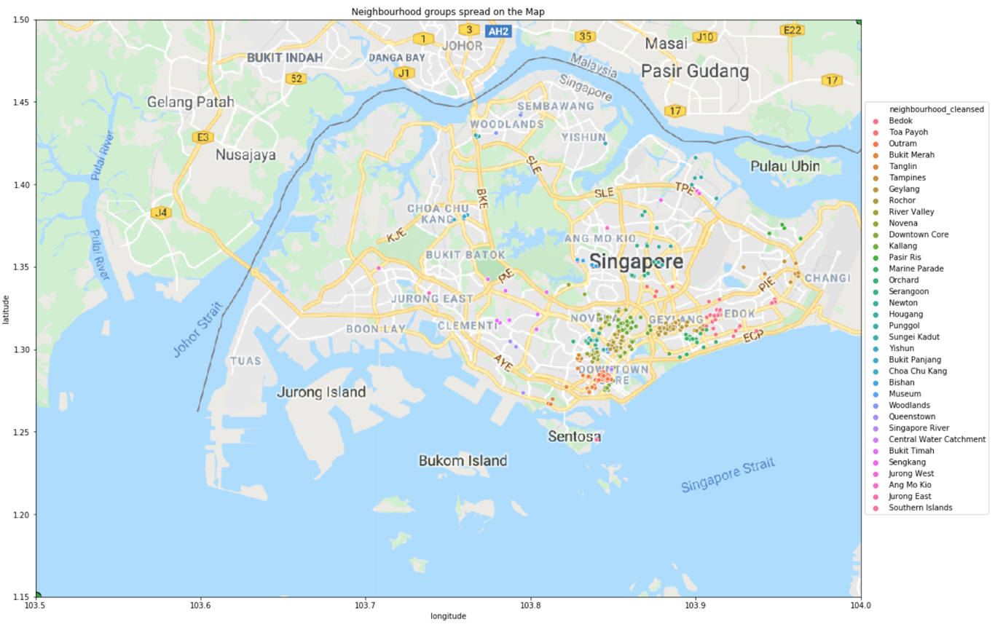

Map of Singapore showing most rated properties vs neighbourhood

From the above map, we can see that the majority of the properties rated in the central area. This was bound to happen because that area is where the majority of guests stay.

**Question 5: Availability of the rooms**

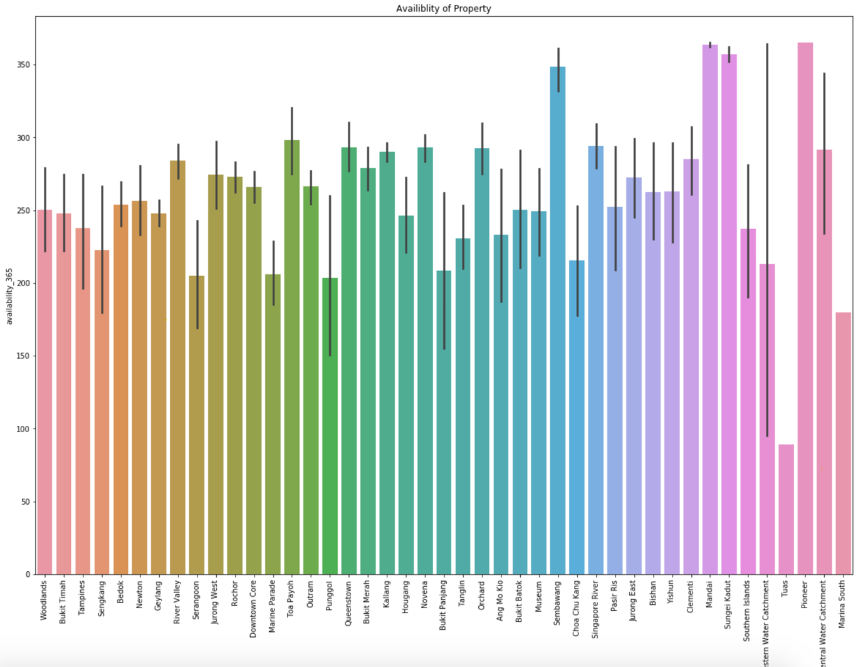

Bar graph of availability of property vs neighbourhood

From the above graph we can draw 2 inferences:

1. Airbnbing houses is a very good business for the people of Singapore.
2. Majority of the rooms in various neighbourhoods are available for more than 200 days which says that Singapore has all-round year tourist activities.

**Question 6: Amenities**

I have sought to examine which are the most common amenities commonly available, but some are seldom provided. I was still trying to find out which services were often provided by high-end rentals.

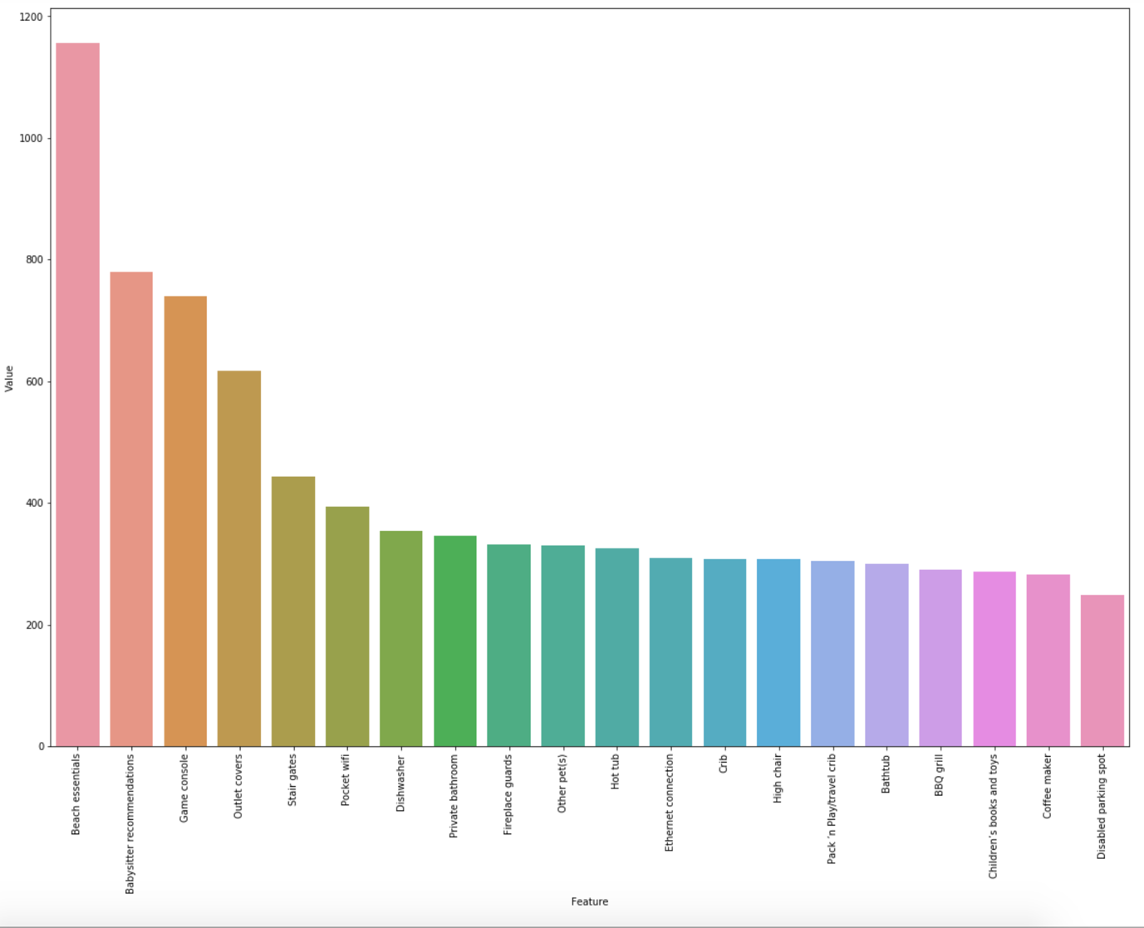

Bar Graph of Amenities vs Price

Some of the amenities provided by *high end* rentals are —**beach essentials, Babysitter recommendations, game consoles and outdoor covers** on the rentals. While amenities like **children’s toys**, **coffee maker** and **disabled parking spots**are offered by *economical* rentals as well.

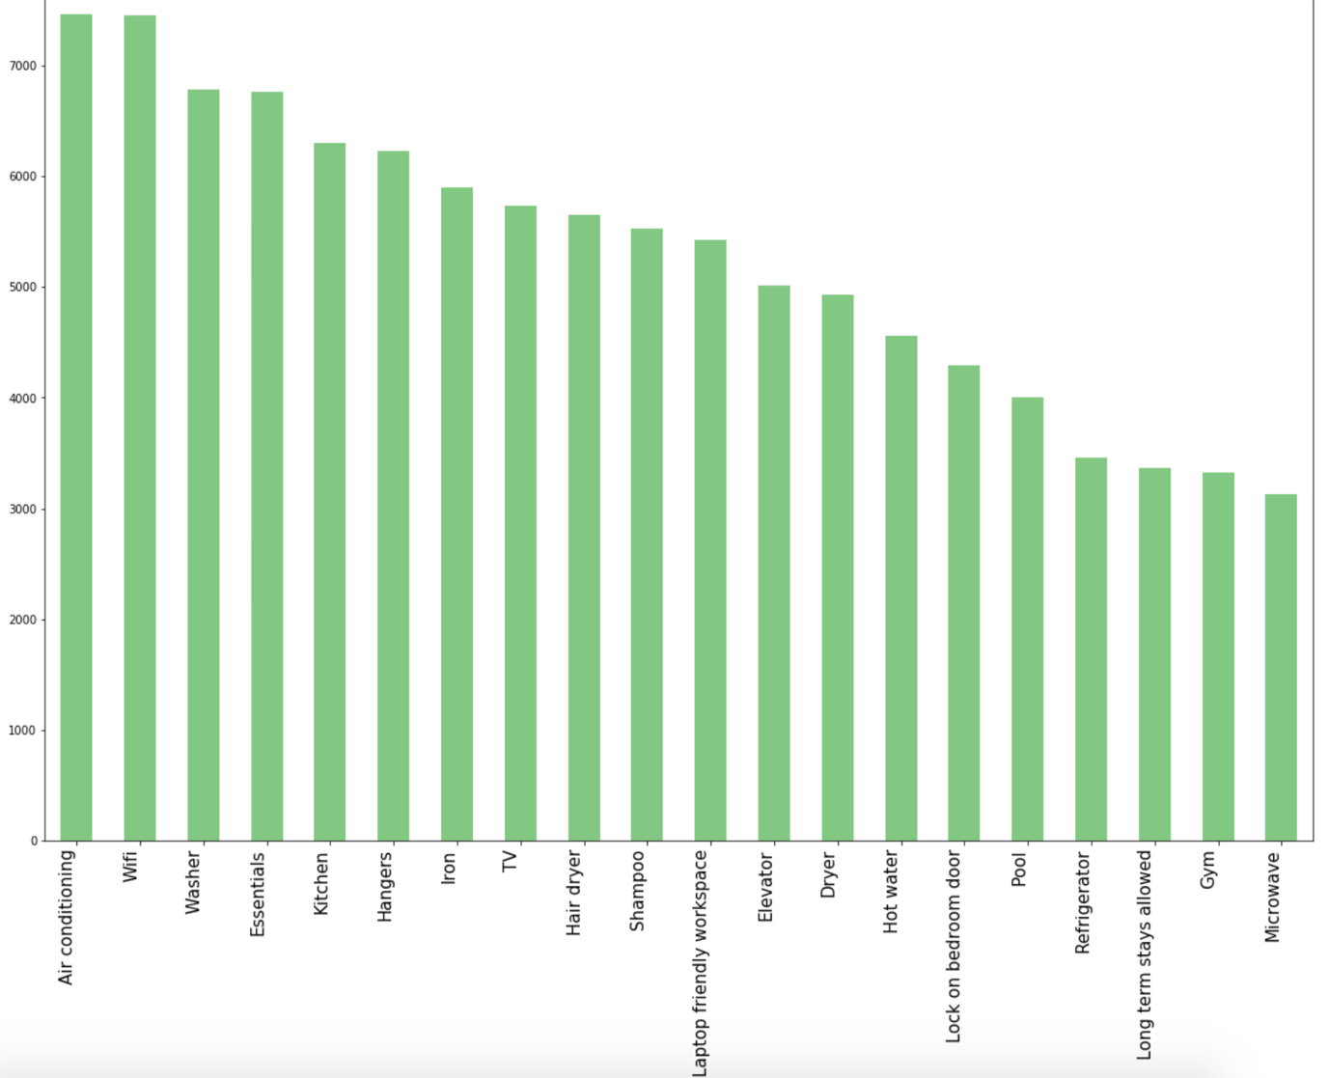

Bar Graph to visualize amenities’ popularity in listings of Singapore Airbnb

**AC**, **wifi**, **washer** and **essentials** are some most *popular* amenities while amenities like **long term stays**, **gym** and **microwave** are *uncommon* and rarely offered.

**Key takeaways**

1. Most people prefer entire homes.
2. The central area is the one which is prefered by the majority of the tourists. It is also the most expensive neighbourhood in Singapore. It is also the most reviewed area.
3. Majority of the properties are ranging between 1 dollar and 500 dollars. (97% of the dataset)
4. AC, wifi, washer and essentials are some most popular amenities while amenities like long term stays, gym and microwave are uncommon and rarely offered.

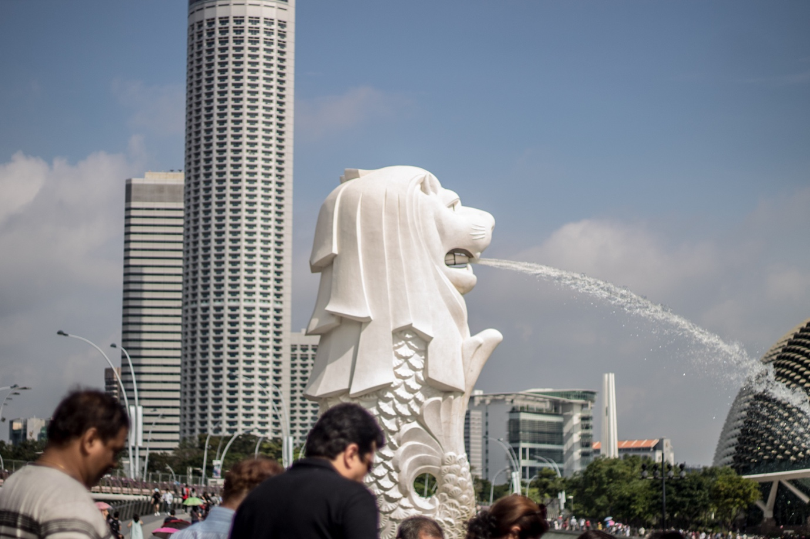

Singapore Airbnb is a vast data set. It includes a lot of information that can be discussed to address other questions such as how host information and ratings influence the quality, what makes a rental busier and more popular than others, what are the peak seasons of visitors in Seattle, etc. This article is just a sneak peek in this dataset. You will find it here if you are interested in more technical specifics of the [article.](https://github.com/rohan27hadvani/Write-a-Blogpost)